11.84: a)
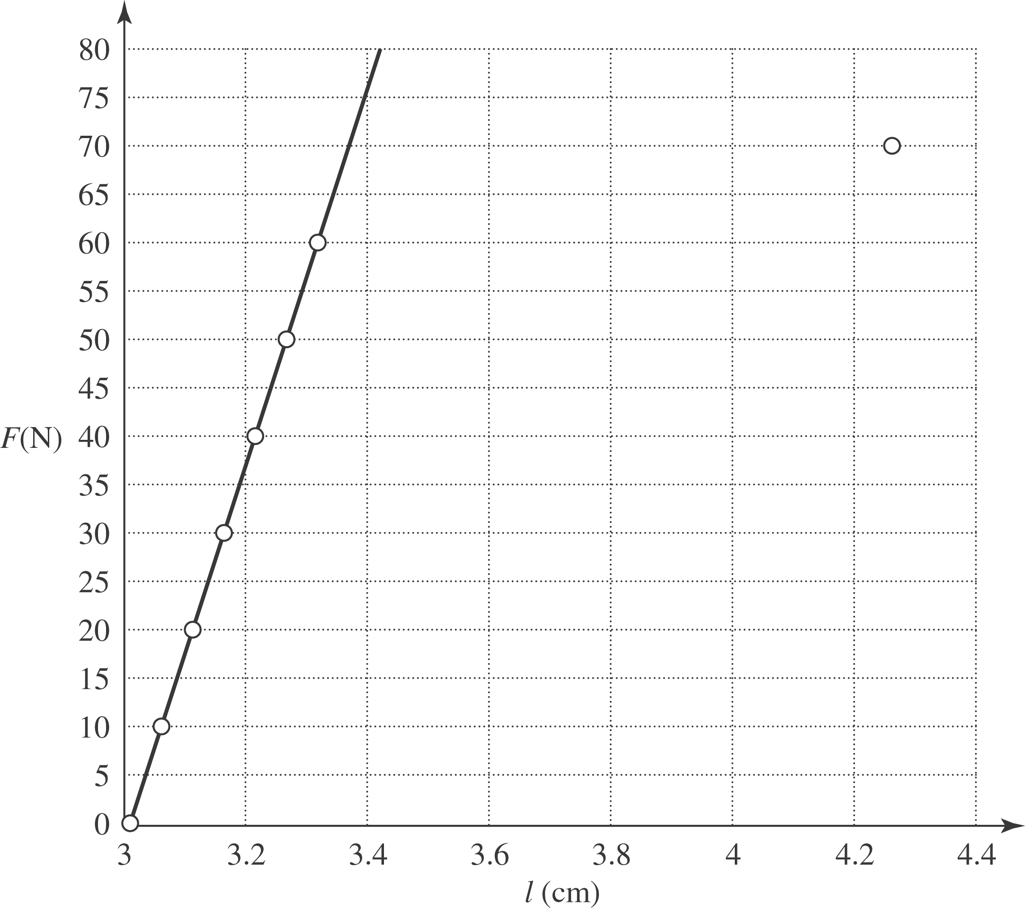

b) The ratio of the added force to the elongation, found from taking the slope of the graph, doing a least-squares fit to the linear part of the data, or from a casual glance at the data gives 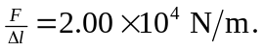From Eq. (11.10),
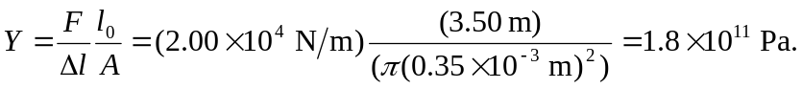
c) The total force at the proportional limit is 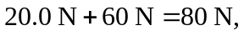and the stress at this limit is 